# Arrays in C++ (Day 01):

01: Finding the smallest number:

Method 01:

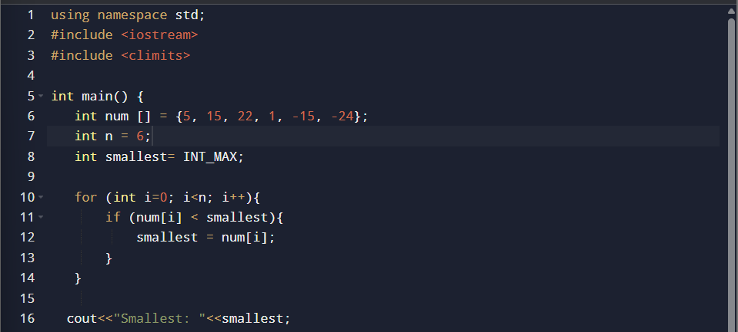



Method 02:

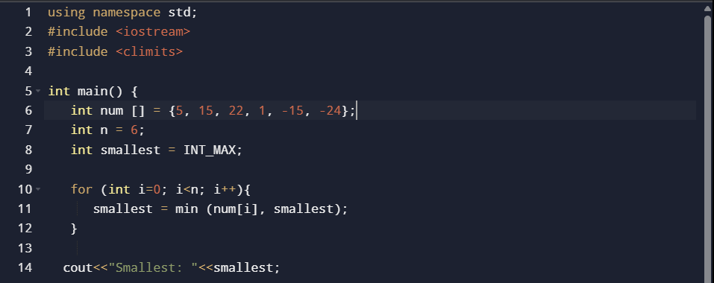



02: Finding the largest number:

Method 01:

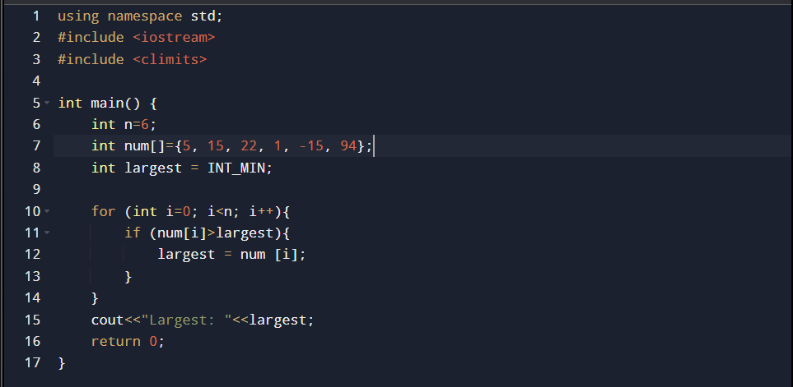

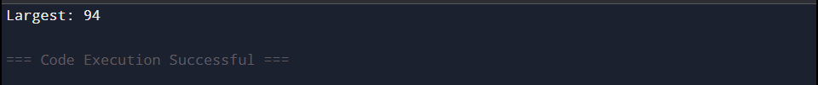

Method 02:



03: Finding both smallest and largest numbers:

Method 01:

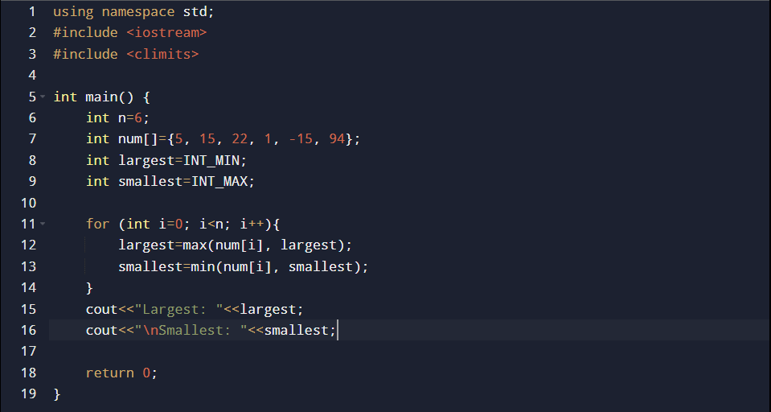

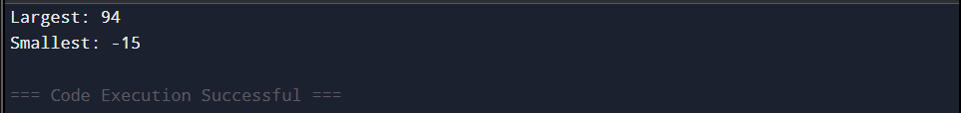

Method 02:

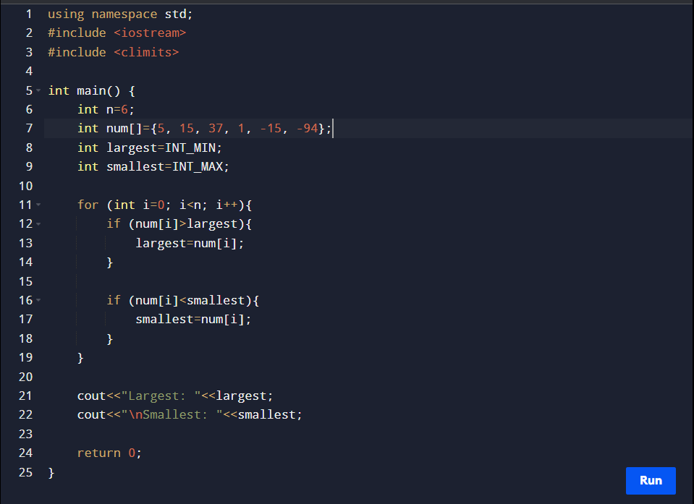

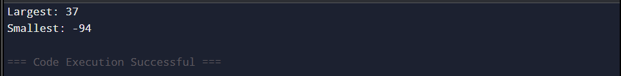

Test :



